**SRI LANKA INSTITUTE OF ADVANCED TECHNOLOGICAL EDUCATION**

**(SLIATE)**

**Title**

**BEE STOCK MANAGEMENT** **SYSTEM**

**Group Project Proposal**

**Group – 07 (Software Track)**

**Supervised by**

**Mr.P.Pirapuraj**

**TEAM MEMBERS**

**S. Katheeskumar (BAT/IT/2018/FT/030)**

**Y. Veanupriyan (BAT/IT/2018/FT/044)**

**HKM. Shaththir (BAT/IT/2018/FT/021)**

**JF. Farhana (BAT/IT/2018/FT/090)**

**MS. Mufasa (BAT/IT/2018/FT/063)**

**Table of Contants**

1. Introduction
2. Background and Motivation
3. Problem in brief

3.1 Lack of security

3.2 Access time

1. Goals and Objectives
   1. Aims
   2. Objectives
2. Proposed Solution
   1. The Design
   2. The main Users
   3. Their Activities
      * 1. Activities Table
3. Process Chart
4. Main Functions (Use case diagram)
5. References

**1. Introduction**

Information Technology is any computer-based tool used to work with information and support the information –processing needs of an organization. Business will increase their efficiency when they embrace information technology.

Today perfect service is only possible if a business has a right information in the hands of the right people at the right time and this can only occur through the appropriate use of information technology. This means that the challenge facing any business is to plan for, develop, manage, and use its three important resources **Information, Information technology, and people.**

This project is concerned with Stock Management System for *Bee Business Organization* in order to make Stock management more efficient and easier to handle. This Stock management is the function of understanding the stock mix of a company and the different demands on that stock. The demands are influenced by both external and internal factors and are balanced by the creation of purchase order requests to keep supplies at a reasonable or prescribed level.

The primary goal of a Stock management is to serve its customers. In this age of information technology, a business can gain the competitive advantage when it uses information technology to its maximum.

**2.Background and motivation**

The main objective of this Bee Business Organization project stock management system is to overcome the work load and time consumption which makes the maintenance of the stock in an organization as a tedious process. This project provides complete information about the details of the stock to the users.

This project identifies the amount of stock available, the product that is purchased faults in the product, products that are replaced, products that have been sold, and the date at which the products are bought and sold in a particular concern.

Separate modules have been created for purchasing, viewing stock details, selling, details and delivery details. As a whole, marketing process can be improved if stock has been maintained properly.

**3.Problems in brief**

Every company needs to keep detailed records in order to maintain normal and efficient operations. Company can keep up with a growing client base and adjust to changes. In a growing business, change is inevitable over time and businesses need to be able to fluctuate. Poor records can lead to damaged business relationships and delays in virtually every department in the company from day-to-day operations to accounting and human resources.

* 1. **Lack of security**

Paper document filing can be less secure than electronic filing systems. Misplaced documents can easily be placed in the wrong hands. Clients expect their information to be secure in your hands. If you can’t keep this safe, you are at risk for losing them

* 1. **Access time**

Manual document filing is very time consuming. Not only do you have to organize and store the files, hunting down the information when it is need can take time

**4. Goals & Objectives**

**4.1 Goal**

Stock management is essential for a business to succeed. Good management of your organization’s stock decreases excess inventory and ensures that you have enough product on hand to meet customer demand. Develop a Stock management plan to streamline ordering and reduce wasted time on inventory control.

* 1. **Objective**

The objectives of stock management are to provide the desired level of customer service, to allow cost-efficient operations, and to minimize the inventory investment

* To facilitate furnishing of data for short term and long-term planning and control of inventory.
* Improve an organization business service
* Help the store keeper with management information.
* It helps to check whether stock is available or not

1. **Proposed solution**

The manual stock management is to develop a computerized stock management system. Before developing the proposed system, there is need to identify.

## **The Design**

The proposed system will be designed using Net beans and MySQL as the back end (the database used to store the Stock details, Income details, Outgoing Issue Details, Payment type and Customer Details and Customer Account Details).

## **The main users**

The main users of the proposed system are the Customers and the Company Owner.

## **Their activities**

The activities of the main users of the proposed system are listed in a table below.

|  |  |
| --- | --- |
| **Activities of staffs** | **Activities of Owner / Admin.** |
| * Search the Item * Sell the Item * Inward Item * Print bills * Add new customer | * Add/Delete/Update Item’s details * Add/Delete/Update Vendor’s details * Add/Delete/Update Customer’s details * View and Maintain the Account Details |

1. **Process Chart**

|  |  |  |  |  |  |  |
| --- | --- | --- | --- | --- | --- | --- |
|  | Collecting Requirement | Planning | Design | Development | Testing | Maintenance |
| 1st week |  |  |  |  |  |  |
| 2nd week |  |  |  |  |  |  |
| 3rd week |  |  |  |  |  |  |
| 4th week |  |  |  |  |  |  |
| 5th week |  |  |  |  |  |  |
| 6th week |  |  |  |  |  |  |
| 7th week |  |  |  |  |  |  |
| 8th week |  |  |  |  |  |  |
| 9th week |  |  |  |  |  |  |
| 10th week |  |  |  |  |  |  |
| 11th week |  |  |  |  |  |  |
| 12th week |  |  |  |  |  |  |
| 13th week |  |  |  |  |  |  |
| 14th week |  |  |  |  |  |  |
| 15th week |  |  |  |  |  |  |

1. **Main Functions (Use case diagram)**

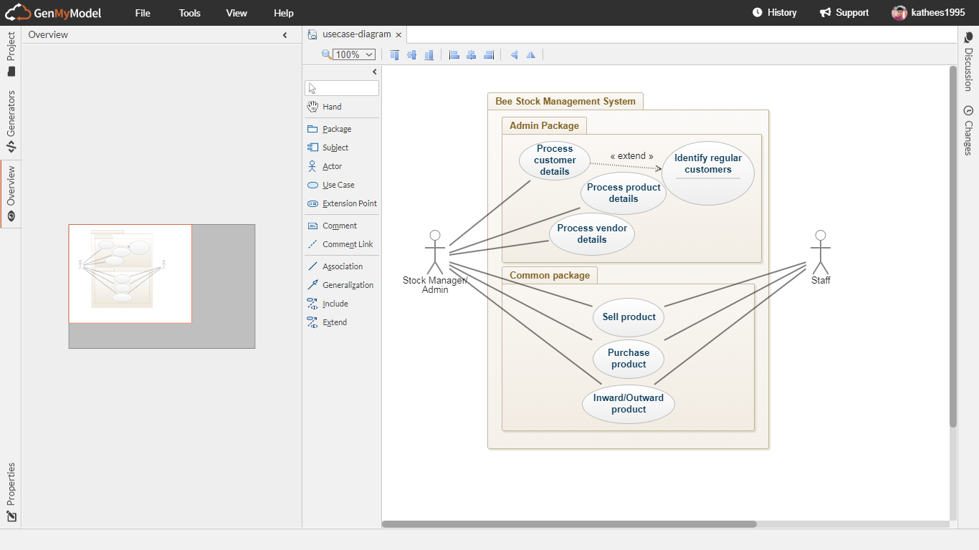

1. **References**

<https://www.electronjs.org>

<https://www.laravel.com>

<https://www.stackoverflow.com>